**Smart Stick for the impaired for Obstacle Avoidance**

Student Name: Hamza Afzal

Student ID: 30052265

Supervisor: Ben Mehenni

University of South Wales, Treforest, Cardiff

Contents

Introduction 3

Background Research of the project 3

Proposed 3D Model 4

Diagrams 6

Current Voltage Specification Table 7

Hardware 7

Risk Assessment 10

Gantt Chart 11

Current State of the Project 11

References 12

Table of Figures 12

# Introduction

We will be making Automatic Guidance system for the impaired which has the ability to avoid obstacles. The scope is to create such a device which does not weigh a lot as well as is mobile so the user can carry it anywhere. In addition to this the goal is to make it in the minimum possible budget.

The core of our project is the Ultra Sonic Sensing technology. It is how we will be able to sense if there is an obstacle or not. This will be backed by an Arduino Nano. It has an ATmega 328 microcontroller(Arduino, n.d.) which should be perfect to handle our task. One of our aim is to make this thing as compact and clean as possible, that is also one of the reason why Arduino Nano is our first choice. In Addition to this, it has the required number of pins, so going with another board might’ve been inefficient as we wouldn’t be using all the pins as well as it would be price along it being bigger in size than the Arduino Nano. We can also take a 5V and 3.3V supply from Arduino. But we suspect that it won’t be able to supply enough current as we require more furthermore this might cause overheating. Hence the solution to this problem is that we use an external power supply. For the moment, we decided that we will go with rechargeable 4 Ni-Mh [ADD CAPACITY].

Furthermore, we have a water sensor in our order form. We will be ordering a water sensor, but it will be decided whether to use it or not after we are done with the prototyping. The purpose of it is to detect puddle but we are suspicious of how good the Ultrasonic Sensor for is detecting a water puddle. Lastly, our smart blind stick will be equipped with DF Mini MP3 Player which will output audio depending on the condition to guide the user. The output will be to an earphone which will be wired

# Background Research of the project

In this section we will be discussing the thoughts we went through and justifying the decisions we have taken along with the respective options we had available. We will also go through the objections we had on these options and why didn’t we choose them.

First of all, we wanted to use a microprogramming or a prototyping kit which is versatile. Arduino was our number one choice because it already has all the libraries established to work with the sensors (Arduino, n.d.). We did have Raspberry Pi as an option as well, but we lack experience in working with Raspberry Pi hence lack of knowledge as well which made us hesitant to use it. We chose Arduino Nano specifically because it fulfilled our needs such as the required number of pins. If we went for a bigger board, we’d have extra pin as well as we’d have to pay extra for it. It is tiny in size so it’d help us keep our project compact . We also considered the idea of using the processor standalone, but we’d need to do extra work to program it e.g. installing bootloader and require extra components e.g. crystal oscillator. Therefore Arduino Nano was the best choice.

Next, Ultra Sonic sensor were chosen after thorough research. We considered all options available. These included LiDar, Camera and Infrared sensors. LiDar and Camera are expensive systems so they were out of the equation. Infrared Sensors don’t work well if surface properties of objects are unknown (Mohammad, n.d.) although they are cheap compared to Ultra Sonic Sensors. The datasheet for the ultrasonic sensor do tell us that their measurement angle of around 30 degrees (Cytron Technologies Sdn. Bhd, n.d.).

We needed something which could intimidate the user that there is an obstacle hence turn right or turn left. We could do this using a buzzer. An example could be that 3 beeps of the buzzer represent an obstacle at left and 2 beeps represent an obstacle on the right. But that will make the user feel awkward in the public moreover this might disturb people who are near the user. Another consideration was using vibration motor modules which generate vibration, and idea was to use 3 of them, for front, right and left. But it’s obvious that constant or periodic vibrations might be really irritating for a user. Furthermore they might also create difficulty in controlling the stick, as stick is a light object. During our research we came across a module called DF Mini MP3 player. This device stores your audios using SD card and we can get the desired audio output when a condition is matched. This voice is transmitted through wired speaker or handsfree. This is a much more suitable solution, no one will get disturbed around the user as there will be no beep sounds. The user will feel much more comfortable because there will be no vibrations. Furthermore, we will be able to keep the project much cleaner in appearance as we will not be using 3 vibration motors. We had other options for audio playback modules like ISD1820, but it stores only one audio and ISD1932 which is not available online, apparently discontinued.

In addition to this we will be using a water sensor. The idea behind this is to detect puddles. Puddle is also considered as an obstacle as it causes hinderance in movement of a person. Water sensor obviously detects if there is water or not. The issue is that how well this idea works practically. A doubt in mind we have is if a person is moving too fast, the sensor might not be able to detect that there is water or not. Even if does will the processor will be fast enough to process it and pass it on to the MP3 player for an output. That is why we have ordered a water sensor as well along with other components.

# Proposed 3D Model

Figure , Front View

Figure 1 shows the Front view of the stick. Disclaimer: The model is for showcase only; actual dimensions and appearance will differ.

At the top we will have the PCB. We will run a narrow pipe in the middle or some sort of casing to cover the wires. Along with the PCB, we will have one ultrasonic sensor as well. At the bottom we will have two ultrasonic sensors along with the water sensor underneath them. Ultrasonic sensors will be at angle to maximize the coverage. The original idea was to put ultrasonic sensor in a casing but this will totally depend on how that effects the performance of the sensor. We plan to go with a 3D printed casing for all the components.

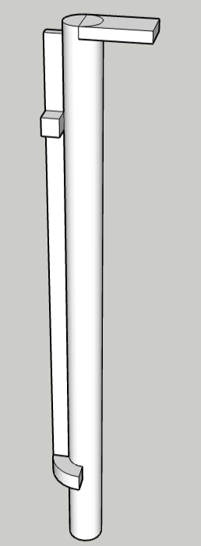

Figure , Side View

The figure above depicts the side view of the proposed model.

# Diagrams

Figure , Block Diagram

The diagram, Figure 3, illustrates how the components will be connected. We will have one common power supply for all the components. Ultrasonic sensors and Water sensor are connected to Arduino. Whereas the DF Mini is connected to the Arduino but for output purpose as it acts as a bridge between the earphones and Arduino.

Flowchart on the left displays the algorithm which we will be implementing. It will check if there is an obstacle. If there is none, it will check again. But if there is one it will determine where it is. Then it will signal the DF Mini to send an output via Wired Earphones. The output will contain guidance e.g turn slight right or turn slight left.

Figure ,Program Flowchart

# Current Voltage Specification Table

|  |  |  |
| --- | --- | --- |
| Name | Voltage | Current |
| Arduino | 5V | 19mA (Arduino, n.d.) |
| Water Sensor | 5V | 20mA |
| Ultrasonic Sensor | 5V | 15mA (Cytron Technologies Sdn. Bhd, n.d.) |
| DF Mini | 5V | 20mA (PicAxe, n.d.) |

Table , Current Voltage Specification

# Hardware

1. ArduinoA drawing of a chip

   Description automatically generated

Figure , Mechanical Dimensions of Arduino (Arduino, n.d.)

Figure , Arduino Pin Out Diagram (Arduino, n.d.)

1. Ultrasonic Sensor

Figure , Mechanical Dimensions of HC-SR04 (Cytron Technologies Sdn. Bhd, n.d.)

Figure , Object Measurement at a Distance and Angle (Cytron Technologies Sdn. Bhd, n.d.)

1. Water Sensor

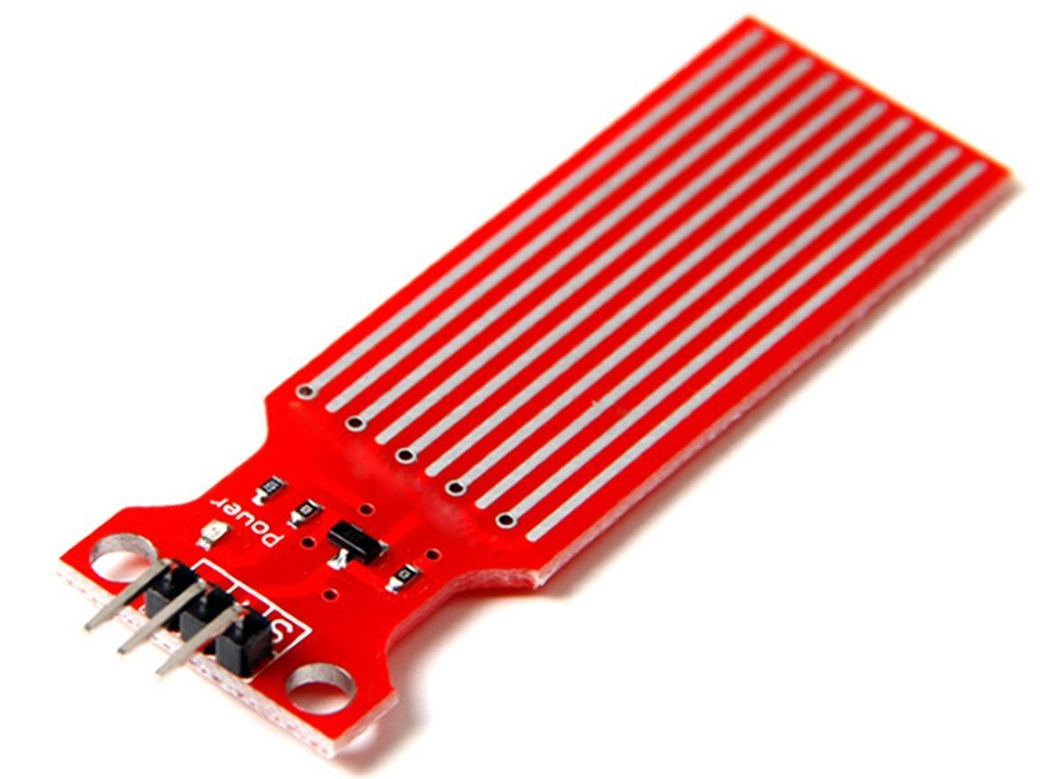

Figure , Water Sensor

1. DF Mini MP3 Player

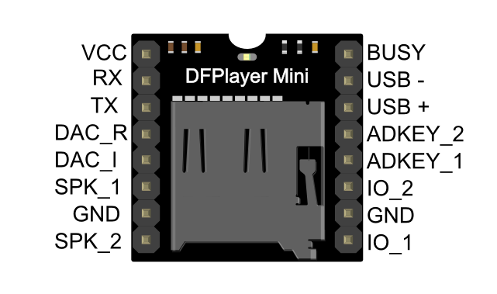

Figure , DF Mini MP3 Player (PicAxe, n.d.)

# Risk Assessment

For our risk assessment we have determined that there are two specific categories of risks, Generic and Specific.

* Generic Risk Assessment.

These are risk which are considered common and can happen any day. Some of these risks are as follows:

1. Theft of Materials
2. Power Outage
3. Tools can go faulty.
4. Delay in components’ delivery.
5. An epidemic
6. Delays due to emergency e.g Medical Reasons, Sick Leave

* Specific Risks

These risks are the ones which are related to my project and components only and can occur anytime but not in another sort of project. A few are described below:

|  |  |  |  |  |
| --- | --- | --- | --- | --- |
| Risk No. | Description of Risk | Probability of the Risk | Effect on the project | Actions to mitigate the risk |
| 1 | Short Circuit leading to fire.  Can Happen due to faulty components or mishandling of wires or battery/power source. | High | Can delay the project. New Components might have to be ordered. | Check each component individually. Before turning on power supply check all the connections thoroughly. |
| 2 | Burn from Soldering.  If soldering iron is not handled with care. | Low | Can damage the effected body parts. Project delay or slow down until healed. | Handle the soldering iron with care. Wear safety gloves. |
| 3 | Data Loss.  Loss of Data e.g documentation and code | Low | Will reset the project if all data is wiped. Will have to redo all the lost data. | Store data on a cloud storage as well. Keep a copy of data in pendrive when possible. |
| 4 | Connectivity Issue.  Due to faulty and malfunctioned copper tracks. | Low | Need to do extra soldering using jumper wires. Will make the project look unclean. | Solder with care.  Don’t apply too much heat on the PCB. |
| 5 | Heat. Due to high data processing demand among components. | Low | Can damage/Malfunction  components hence will need to reorder. | Proper ventilation for components. Use heatsinks where possible. |
| 6 | Sensing Limitation.  Sensing can be affected due to various conditions such as atmospheric effects. Sensor by default are limited in sensing data in certain conditions. | Medium | Outliers in the data. | Use the sensor according to the manufacturers guideline and given optimum conditions. |

Table , Risk Assessment

# Gantt Chart

Figure , Gantt Chart

The above is our Gantt Chart. We are almost in line with what we have planned. We will follow it as far as there are no external interventions described in the risk assessment as well as other than that.

# Current State of the Project

Current State of the project is that we are ready to submit the Order Form. We will be waiting for the delivery of the components. Meanwhile, we are designing the circuit as well as the program to run the Arduino on. Once we get the components, we will design a prototype hence the circuit and the program are necessary. After that we will design the chassis as we will have the dimensions. This way we will also be able to design the PCB because we will have the circuits as well as the dimensions. Once we are done with the prototype, we will send another order form the PCB which we should be able to receive in January. So, we should be done with assembly at the end of January.

# References

Arduino, n.d. *Arduino Nano.* [Online]   
Available at: https://store.arduino.cc/products/arduino-nano  
[Accessed 02 November 2023].

Arduino, n.d. *Arduino Nano Data Sheet.* [Online]   
Available at: https://docs.arduino.cc/resources/datasheets/A000005-datasheet.pdf  
[Accessed 04 November 2023].

Arduino, n.d. *Libraries.* [Online]   
Available at: https://www.arduino.cc/reference/en/libraries/  
[Accessed 02 November 2023].

Cytron Technologies Sdn. Bhd, n.d. *Data Sheet for Ultra Sonic sensor.* [Online]   
Available at: https://www.researchgate.net/publication/258883212_Using_Ultrasonic_and_Infrared_Sensors_for_Distance_Measurement  
[Accessed 3 November 2023].

Mohammad, T., n.d. *Using Ultrasonic and Infrared Sensors for.* [Online]   
Available at: https://www.researchgate.net/publication/258883212_Using_Ultrasonic_and_Infrared_Sensors_for_Distance_Measurement  
[Accessed 2023 November 02].

PicAxe, n.d. *DF Player Mini.* [Online]   
Available at: https://picaxe.com/docs/spe033.pdf  
[Accessed 8 November 2023].

# Table of Figures

Figure 1, Front View 4

Figure 2, Side View 5

Figure 3, Block Diagram 6

Figure 4,Program Flowchart 6

Table 1, Current Voltage Specification 7

Figure 5, Mechanical Dimensions of Arduino (Arduino, n.d.) 7

Figure 6, Arduino Pin Out Diagram (Arduino, n.d.) 7

Figure 7, Mechanical Dimensions of HC-SR04 (Cytron Technologies Sdn. Bhd, n.d.) 8

Figure 8, Object Measurement at a Distance and Angle (Cytron Technologies Sdn. Bhd, n.d.) 8

Figure 9, Water Sensor 9

Figure 10, DF Mini MP3 Player (PicAxe, n.d.) 9

Table 2, Risk Assessment 11

Figure 11, Gantt Chart 11